

BIRZEIT UNIVERSITY
Physics Department

Physics 112

Experiment No. 1

Linear and non-linear components
………………………………………………………………………………………

Student’s Name: Mohammad Sheikh Student’s No.: 1221541

Partner’s Name: Mousa Suhaib Partners’ No.: 1210143

Instructor: Shayma’ Salama Section No.: 6

Date: 12-10-2023

- Abstract:

- The aim of the experiment:

To check whether the (carbon resister , Si diode , Light bulb ) are linear or non-linear conductors.

- The method used:
is direct measurements of Voltage and electrical current through those components , then doing the proper calculations.

- The main results are:

The resistor is linear component , whereas the diode and the light bulb aren’t .

I
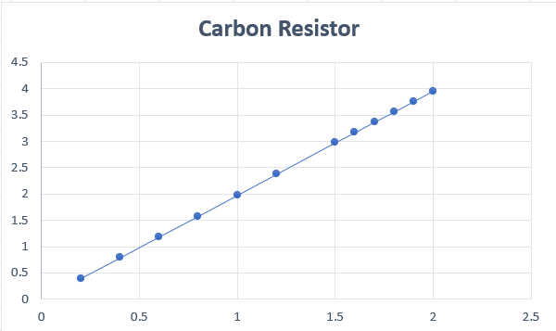
V
We conclude from the figure that the relationship is linear .
Calculation for Carbon Resistor:
The Slope (Resistance):


I
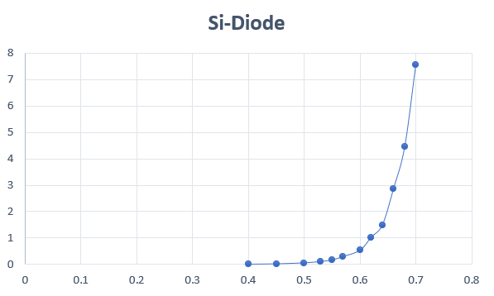
V
This is graph for Si diode . And we conclude from the figure that the relationship is non-linear .
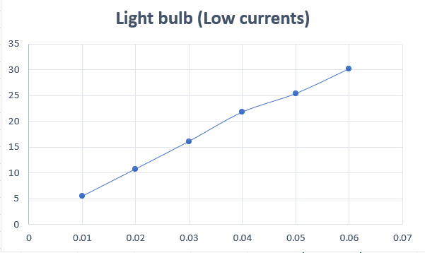
I

V
We conclude from the figure that the relationship is linear.
− Calculation for Light Bulbs (Low Currents):
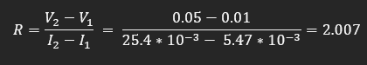

I
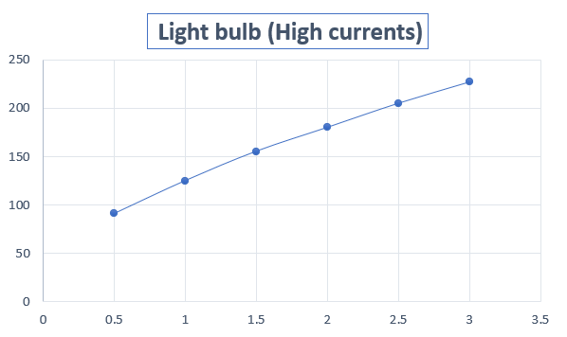
V
We conclude from the figure that the relationship is non-linear.
− Calculation for Light Bulbs (High Currents):
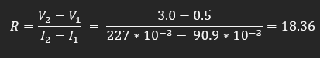

- Calculation:

− The calculations for Temperature of the Lamp :

R= R0 [1+α (T-T0)]
18.36 = 2.007 [1+(4.5 * 10⁻³) * (T-20)]
T =1827.24

And under each graph you find a calculation .

- Results and Conclusion:

- The value of the resistance that we got experimentally , is quite reasonable , since it comes within the range of value we obtained from the color code. R=510
- The carbon resistor is a linear component .
- The diode is non-linear.
- The light bulb with high current non-linear while starting to turn on because of the increase of temperature, and then obtains a linear resistance after a while , but light bulb with low current linear .

So , the Diode and the light bulb are non linear components , and don’t obey Ohm’s law.

